Windows EC2 with IIS

Took Class 9 code. Executed it

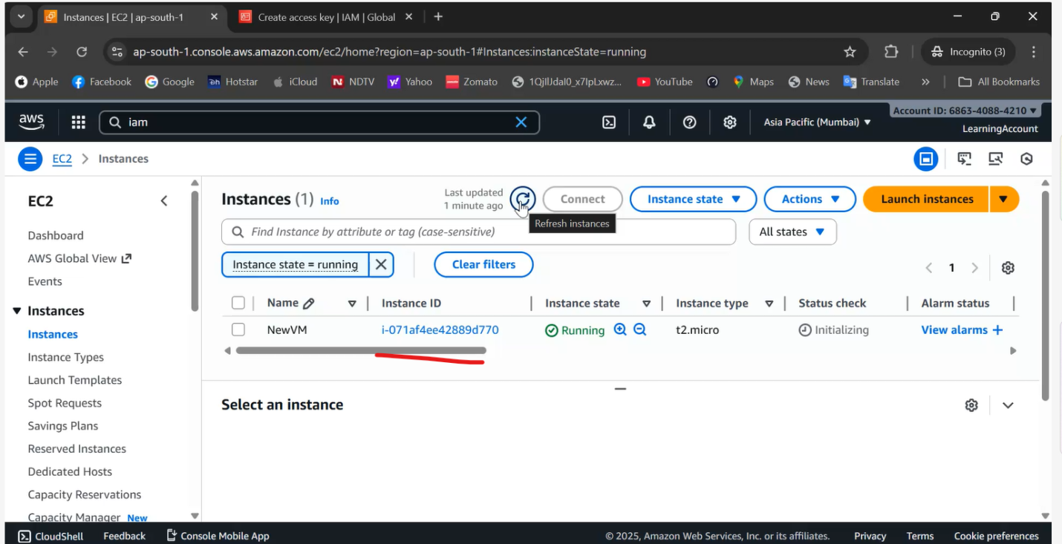

Key did not worked

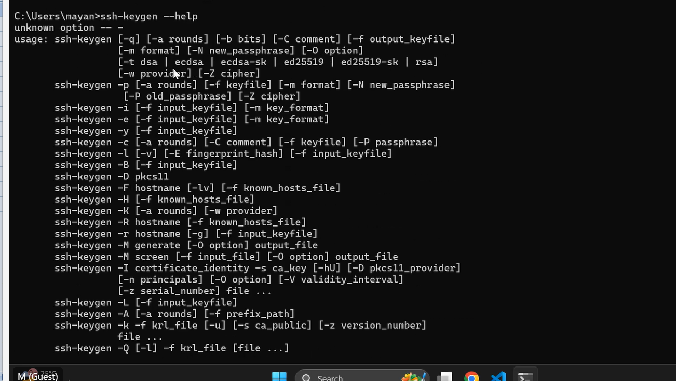

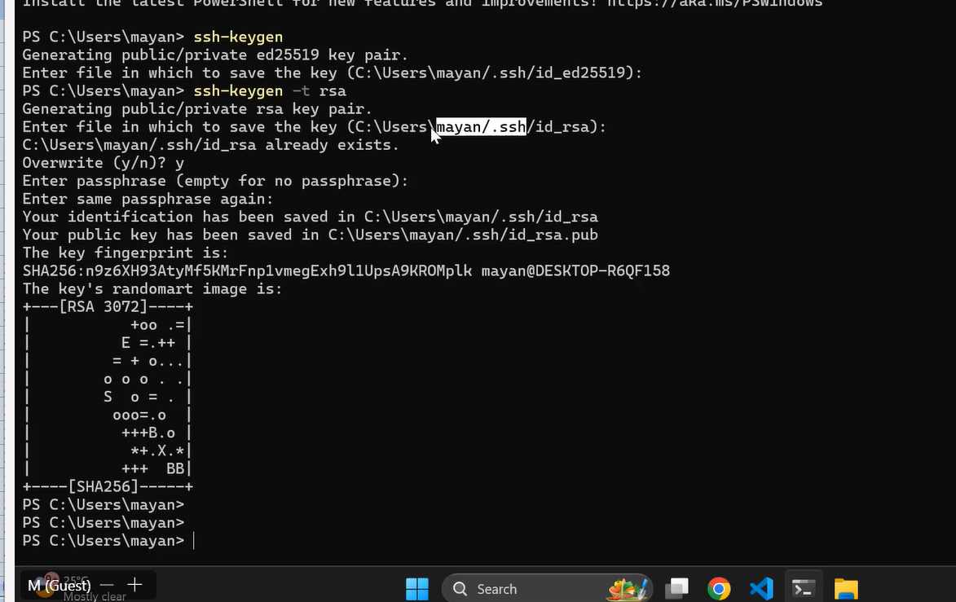

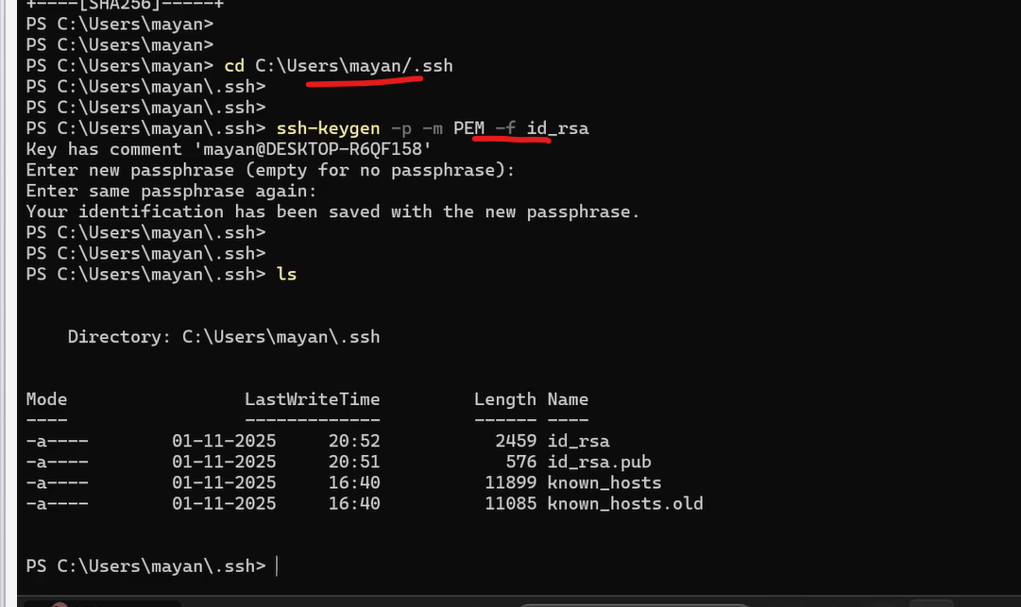

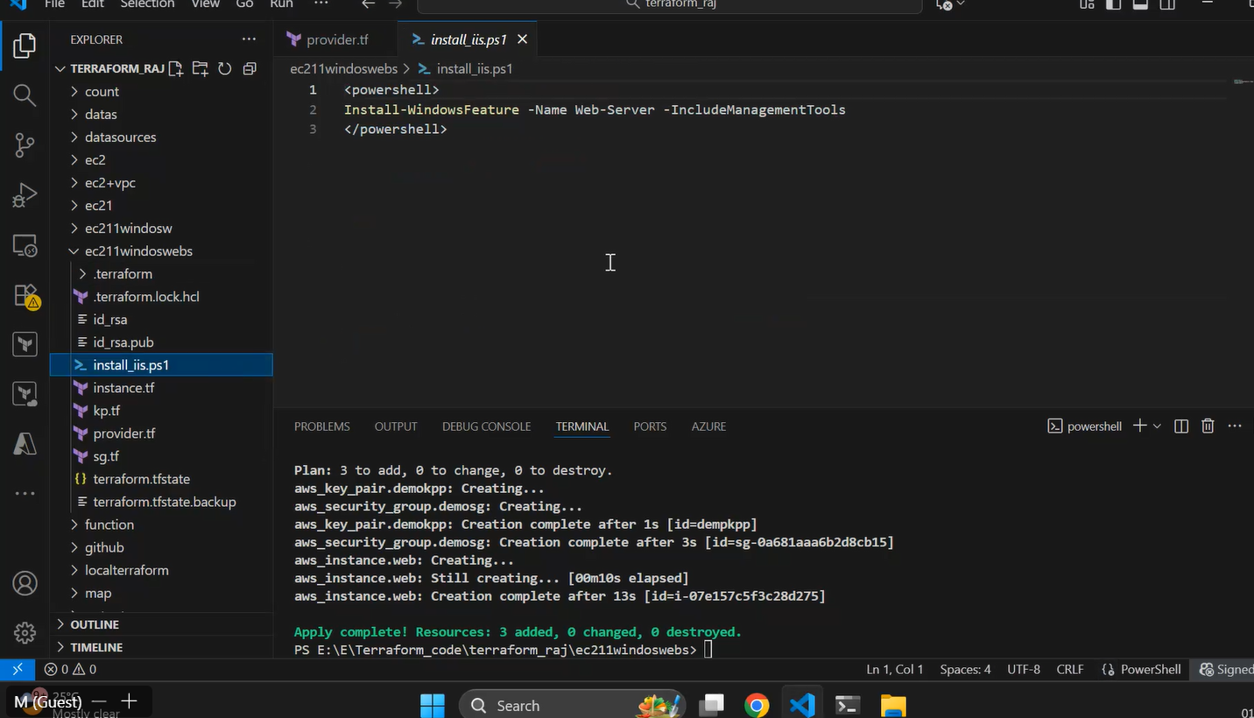

ssh-keygen -p -m PEM -f id_rsa {This is the crucial Step…first he generated key pair id_rsa…{ssh-keygen –t rsa}files ll be tgenerated in .ssh folder….then..navigate to .ssh directory and run the above command…this step Is particularly important for Windows EC2 to generate and to login into Windows EC2…Also if possible try to revist the video from 20th min to 45th min just for troubleshooting purpose…note that id_rsa has new value}

Then he attached EBS manually….

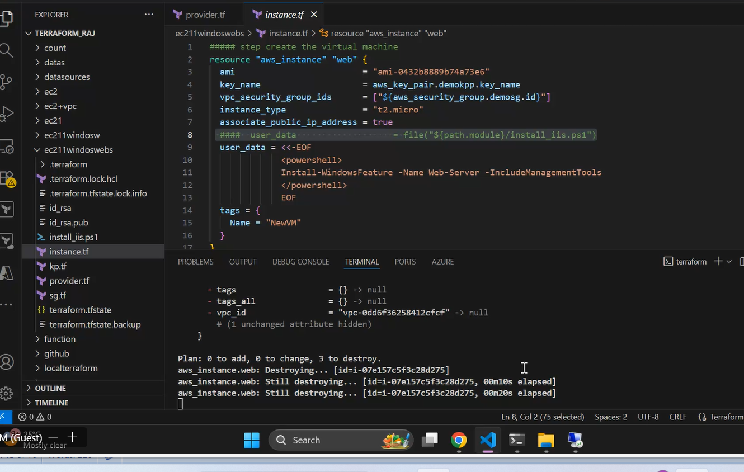

Now he is doing EBS in Terraform

Provider.tf and main.tf

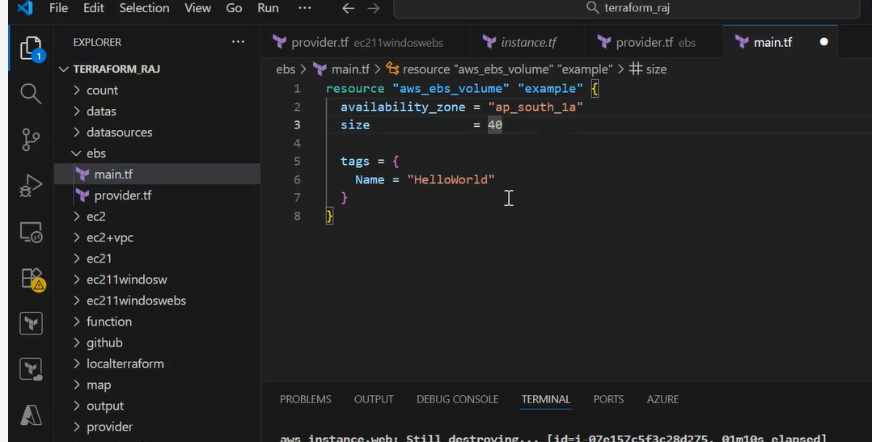

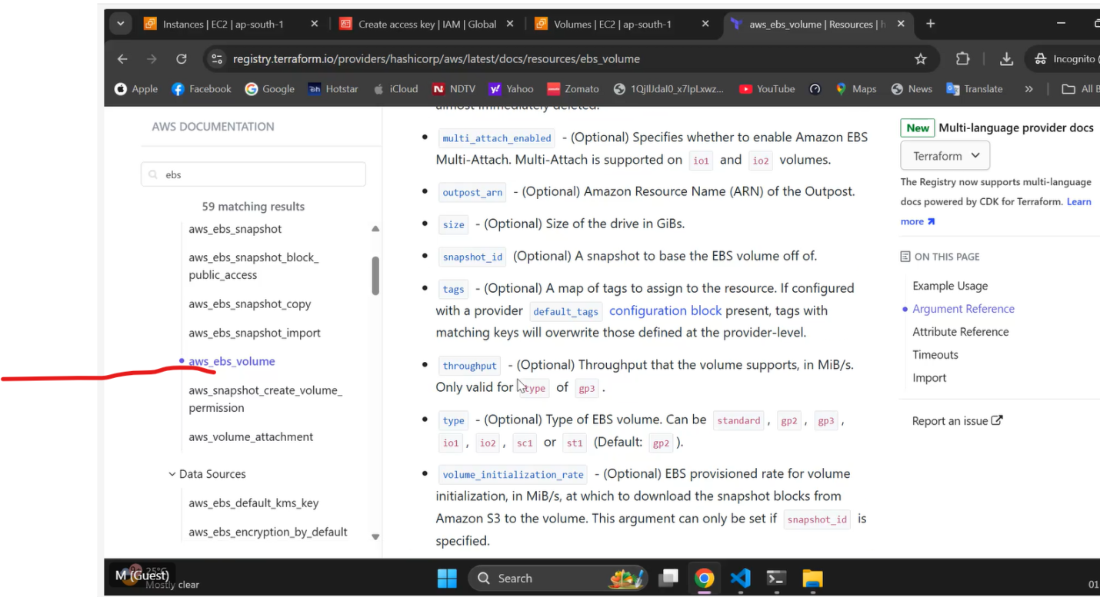

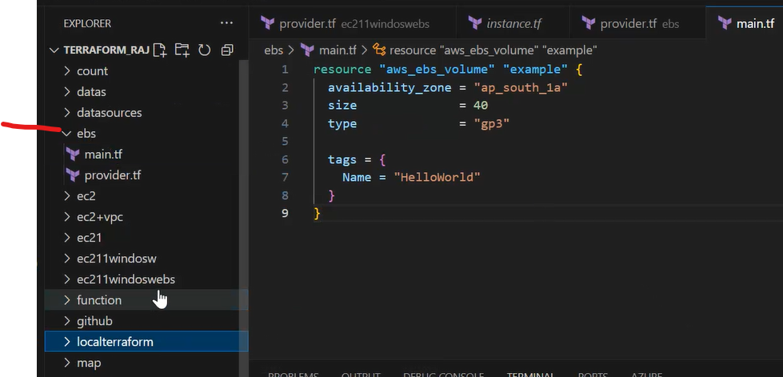

Terraform init, plan and apply….

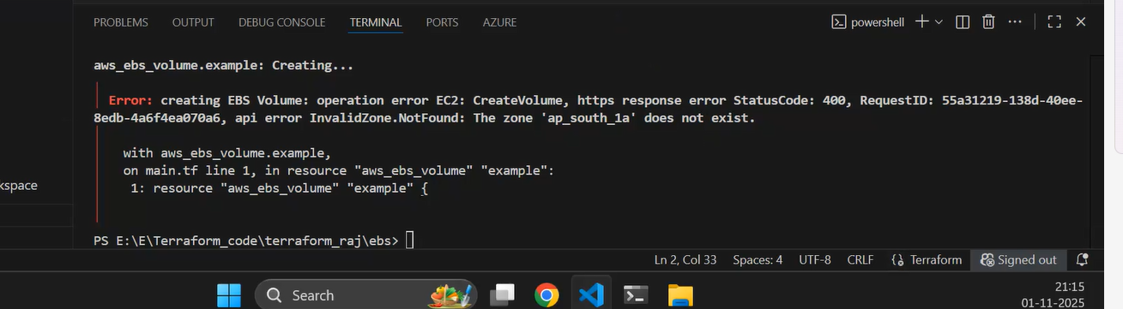AZ….should hv hyphen not underscore…..

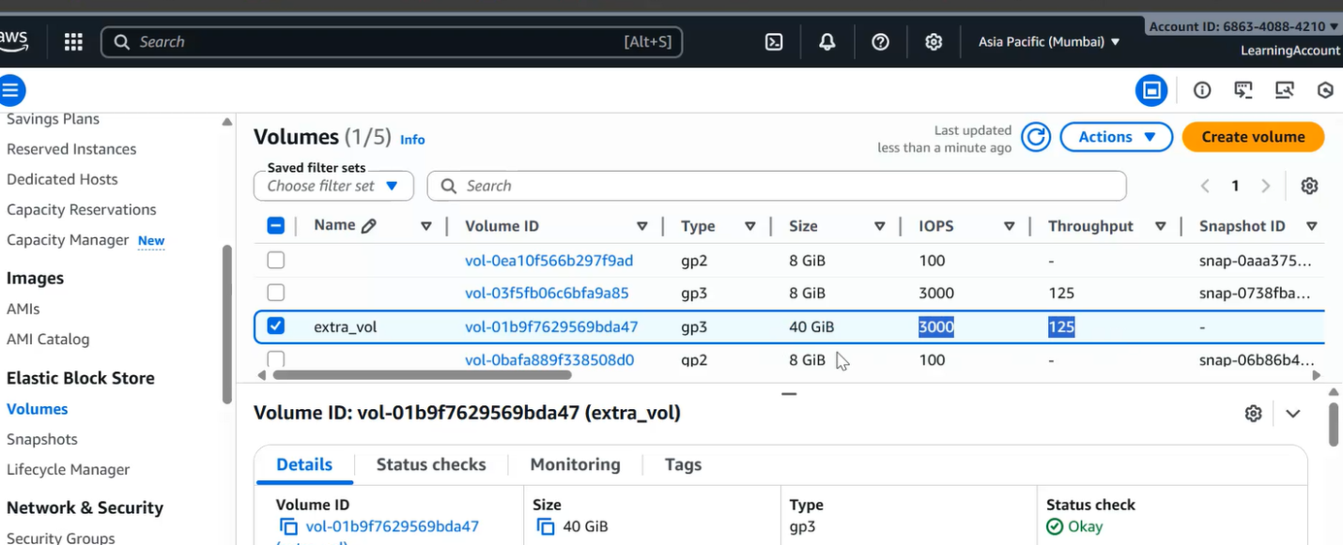

Extra_vol is the name…..

Now he combined to the code with Windows Ec2

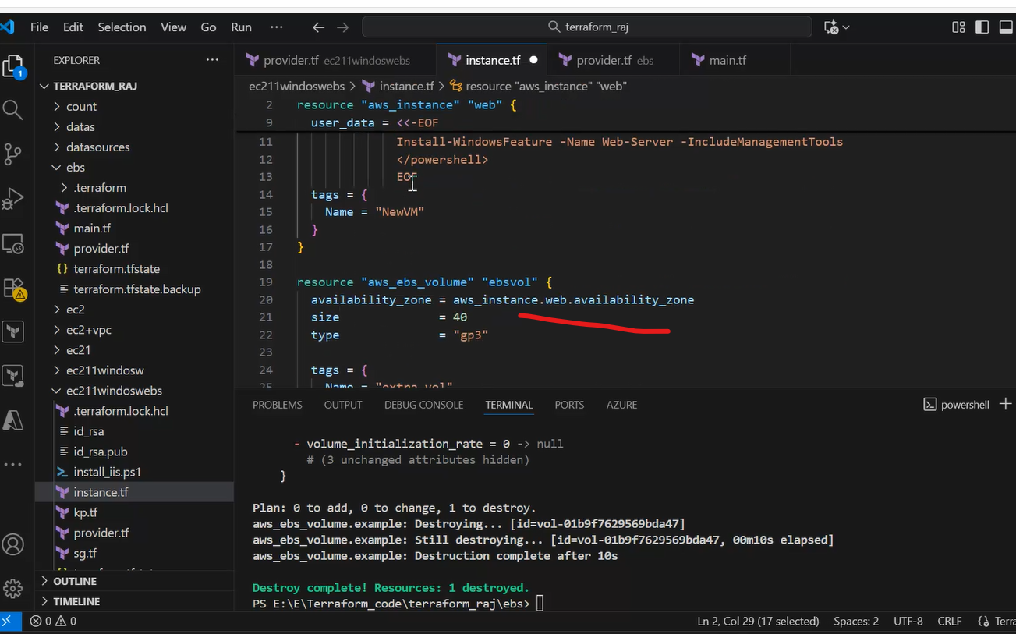

He changed the az of ebs to windows ec2

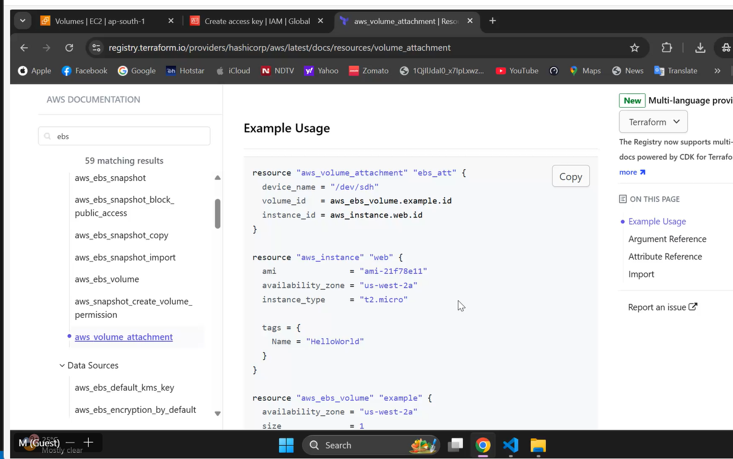

This will associate EBS to EC2

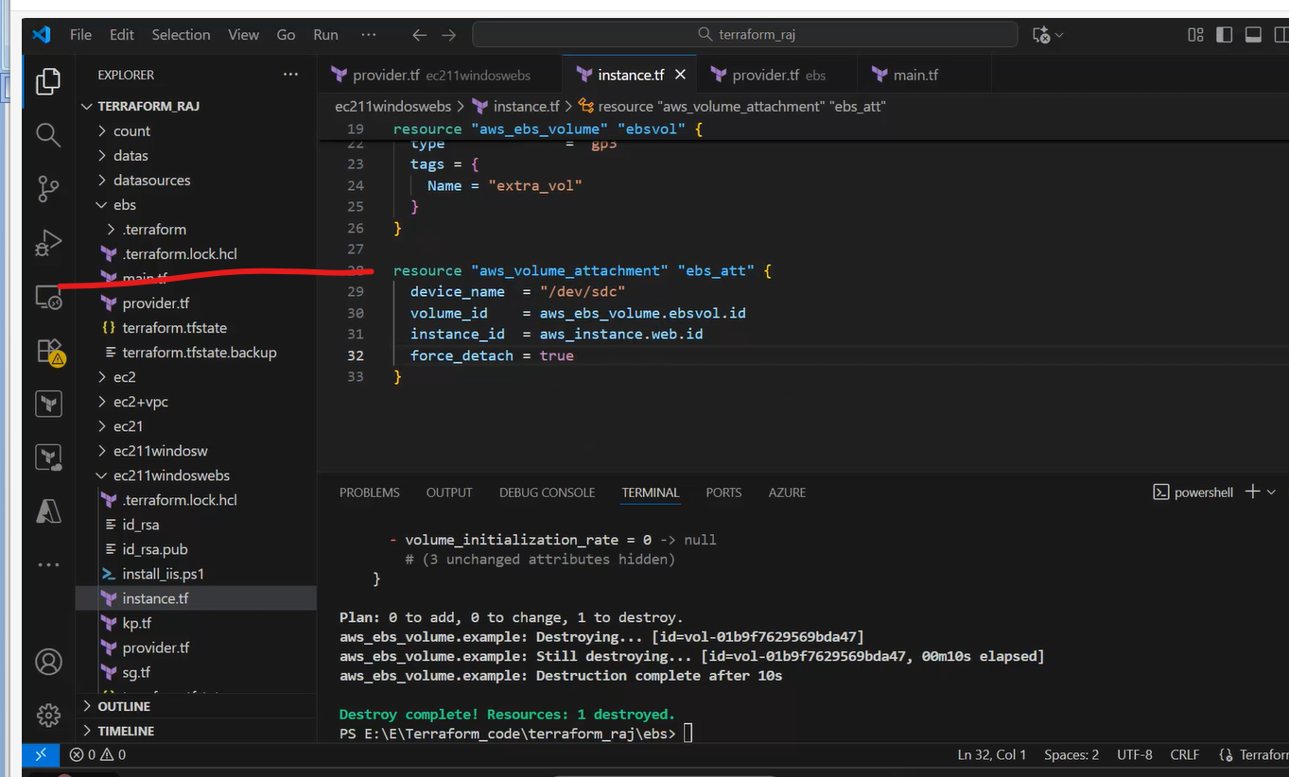

EBS is attached and is verified by loggining into Windows VM

Next Topic is attaching EBS to Linux Machine

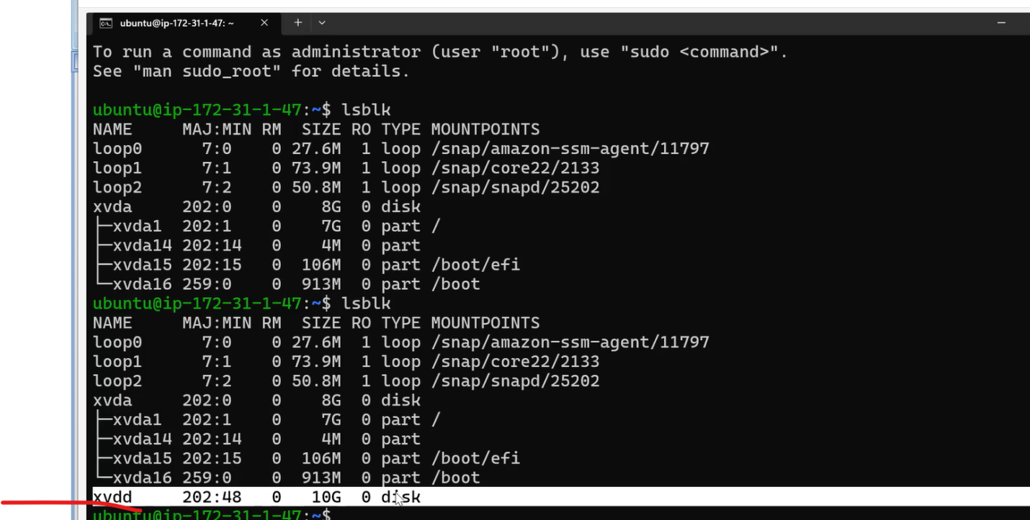

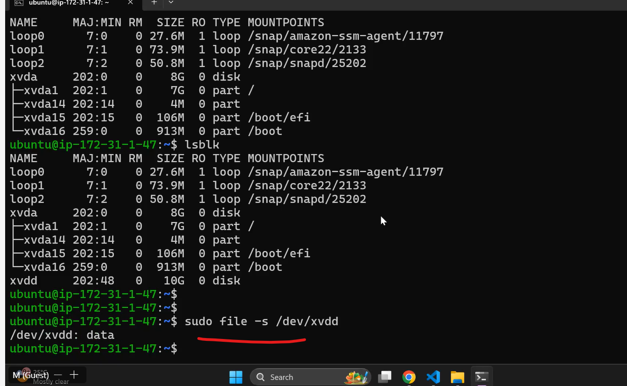

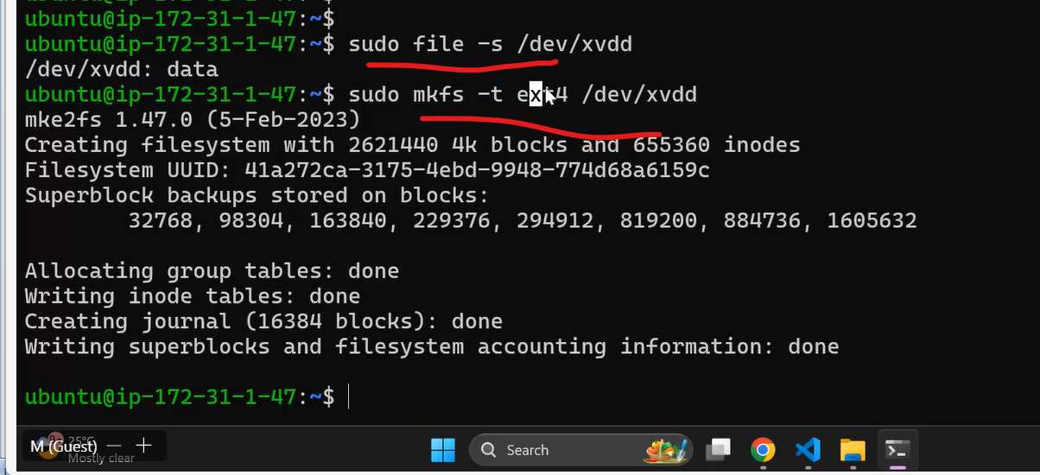

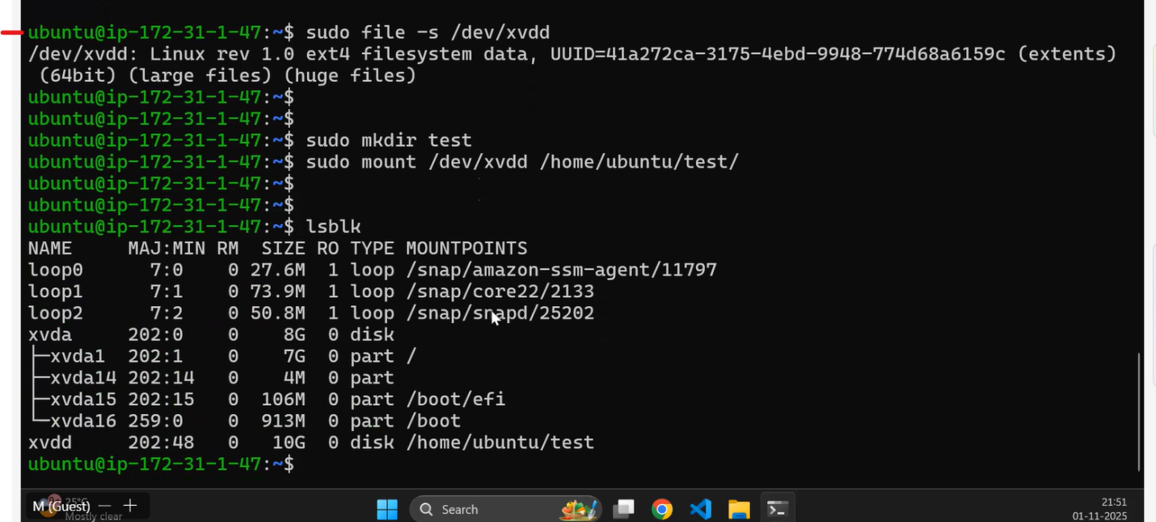

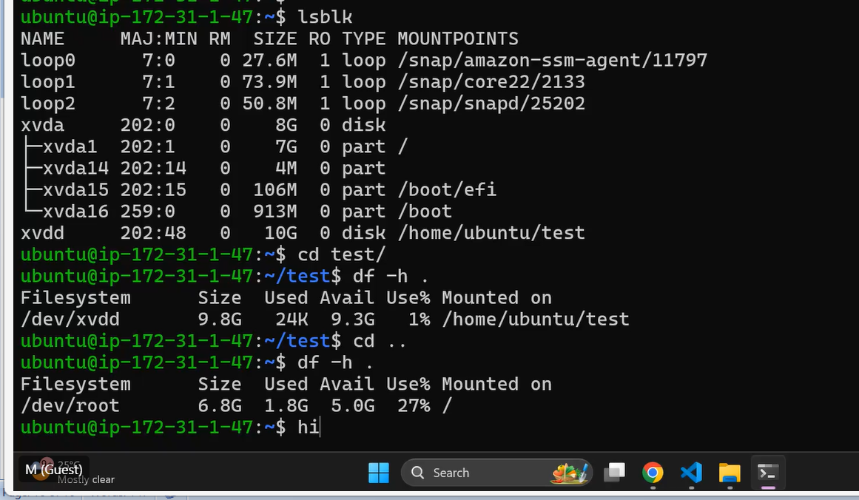

##### step create the virtual machine

resource "aws_instance" "web" {

  ami                         = "ami-0432b8889b74a73e6"

  key_name                    = aws_key_pair.demokpp.key_name

  vpc_security_group_ids      = ["${aws_security_group.demosg.id}"]

  instance_type               = "t2.micro"

  associate_public_ip_address = true

  ####  user_data                   = file("${path.module}/install_iis.ps1")

  user_data = <<-EOF

              <powershell>

              Install-WindowsFeature -Name Web-Server -IncludeManagementTools

              </powershell>

              EOF

  tags = {

    Name = "NewVM"

  }

}

resource "aws_ebs_volume" "ebsvol" {

  availability_zone = aws_instance.web.availability_zone

  size              = 20

  type              = "gp3"

  tags = {

    Name = "extra_vol"

  }

}

resource "aws_volume_attachment" "ebs_att" {

  device_name  = "/dev/sdc"

  volume_id    = aws_ebs_volume.ebsvol.id

  instance_id  = aws_instance.web.id

  force_detach = true

}

##### step create the virtual machine

resource "aws_instance" "web" {

  ami                         = "ami-0432b8889b74a73e6"

  key_name                    = aws_key_pair.demokpp.key_name

  vpc_security_group_ids      = ["${aws_security_group.demosg.id}"]

  instance_type               = "t2.micro"

  associate_public_ip_address = true

  ####  user_data                   = file("${path.module}/install_iis.ps1")

  user_data = <<-EOF

              <powershell>

              Install-WindowsFeature -Name Web-Server -IncludeManagementTools

              </powershell>

              EOF

  tags = {

    Name = "NewVM"

  }

}

resource "aws_ebs_volume" "ebsvol" {

  availability_zone = aws_instance.web.availability_zone

  size              = 20

  type              = "gp3"

  tags = {

    Name = "extra_vol"

  }

}

resource "aws_volume_attachment" "ebs_att" {

  device_name  = "/dev/sdc"

  volume_id    = aws_ebs_volume.ebsvol.id

  instance_id  = aws_instance.web.id

  force_detach = true

}

1  lsblk  
    2  sudo file -s /dev/xvdd  
    3  sudo mkfs -t ext4 /dev/xvdd  
    4  sudo file -s /dev/xvdd  
    5  sudo mkdir test  
    6  sudo mount /dev/xvdd /home/ubuntu/test/  
    7  lsblk  
    8  cd test/  
    9  df -h .  
   10  cd ..  
   11  df -h .  
   12  history

nS72QCp%HL3?(Xy@ucCTce0d$EE*8CEa